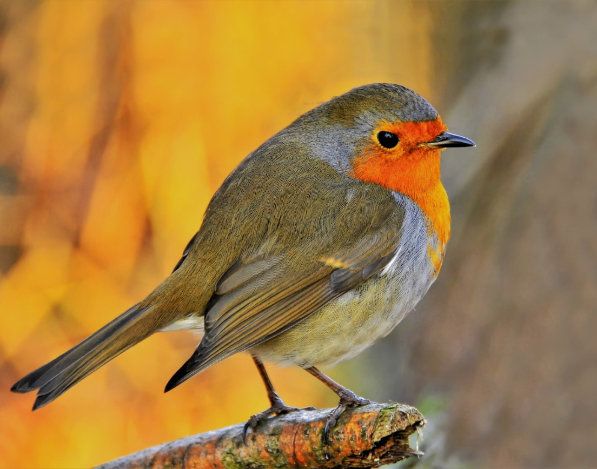

|  |  |  |  |  |
| --- | --- | --- | --- | --- |
| BIRD CLASSIFIER  DSIA.bbM.20.SS21 SOF 29781 - 1 | | |  | JULI | 12 | 2021 |
|  | | |  | Idea  Image classification of birds using a neural network.  **Content**  The user can load a bird picture via a website and get an assessment of which bird species it is.  Particularities  The neural network automatically recognizes the bird species based on the shapes and colors of the image.  **Challenges**  The reprogramming of the Jupyter notebook in object-oriented code, the creation of a web app, working with Docker and the deployment to a free cloud provider. |
| Lessons Learned By  Aichinger-Fankhauser Peter  Barkschat Jens  Bartz Robert  Holzinger Michael  Reckmeyer EmanuelElias  &  Viviane Aicher |  | By dividing the project into LAB and ILV part, the requirements were not only theoretically defined, but also implemented in practice in a first release. It has been shown that active deployment know-how is required in various areas - just having a neural network for image classification is by no means sufficient.  Since the entire group already had knowledge of Python and neural networks through the machine learning courses, but little or no knowledge of Visual Studio Code, Streamlit, Docker and the deployment of web applications, the learning curve was very steep. In addition, CI / CD was used in combination with GitLab. Tests were written, logging was set up and Sphinx documentation was written.  Due to the size of the group, a division into teams of 2/3 was agreed. Unfortunately, this meant that not everyone was able to familiarize themselves with all areas in the same depth. However, an attempt was made to compensate for this through continuous discussions and coordination. | | |